**Arduino yun project Security**

There are so many security risks in 2021 more and more often we seem to hear about security breaches and people’s personal information being compromised. These days everything seems to be connected to the internet so it is important we look at what security we can implement to our project in the future to avoid any security attacks or limit some of the vulnerabilities available to target. The best and possibly most obvious place to start would be with your home Wi-Fi changing from the default password will limit access to any unauthorized users and limit some of the opportunities to attack the Arduino project or the code. Another good option would be to use DCHP where possible to reserve the mac address to avoid the yun being unable to access the network. It would be a smart option in my opinion to use camel casing and numbers and symbols to ensure your password is as difficult as possible for anyone to try and guess. Example Pa$sw0Rd this makes the password difficult for anyone to figure out and its recommended you do not share your password with anyone else. The Arduino yun address 192.168.240.1. can be accessible through the hotspot so it is a good idea to make sure another strong password is used on the interface configuration website and is not left as the default password. Pone other way to add some protection to the project would be the use on online debugger software such as visual micro which is a plug in available via Microsoft that is used to Create cross platform programs on Arduino. For further security and peace of mind it would be a good idea to have regular authentication so we you know any devices on your network are trusted devices you can communicate with and that any communication is private. The next step I would introduce to avoid any physical security breaches such as resetting to default factory settings by pressing the WLAN RST button for longer than thirty seconds. To avoid this I would place the Arduino yun itself in the box pictured below then I would place it in a larger box secured with a lock to avoid any unauthorised access other than the user themselves.

Example cases for physical security

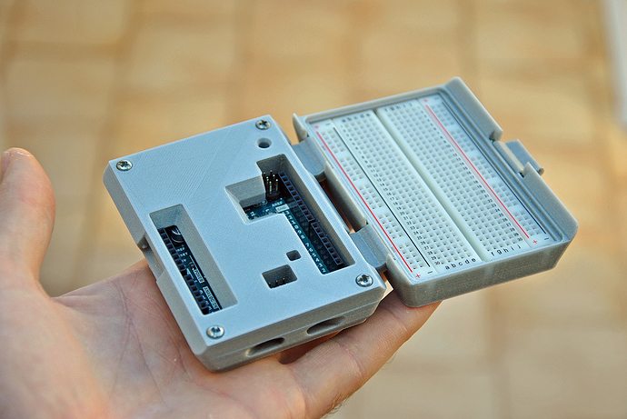 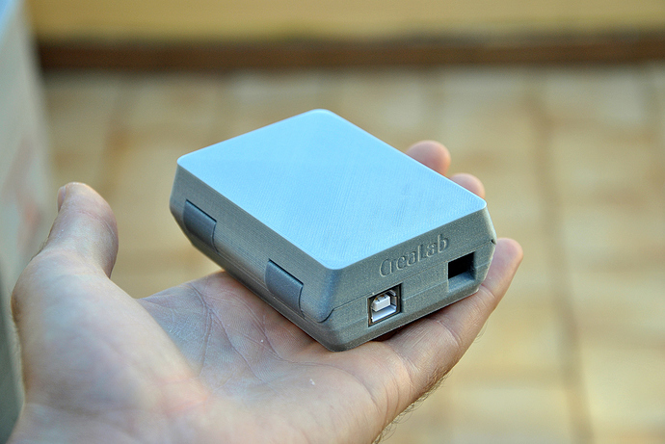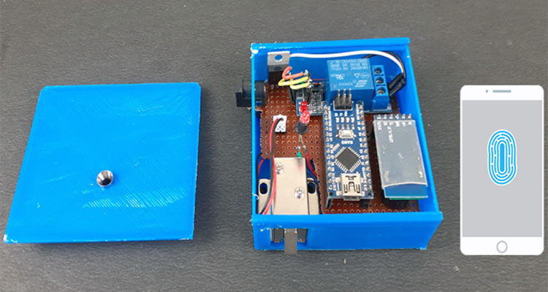

References:

<https://docs.google.com/forms/d/e/1FAIpQLSflkD2mEYdRsqyPBUQxaViIpyXmHT5KD8856fzpqEnpT3sRrA/viewform?c=0&w=1>

<https://blog.arduino.cc/2020/07/02/arduino-security-primer/>

Passpord protect wifi with difficult password

Password protect Arduino yun

Encrypt passwords if possible

Outside protect a box or case for the Arduino and components.